1. PURPOSE
   1. Our database application is designed to store information on board games. A hobbyist interested in a game with an Auction mechanism and has five friends coming over could make a query on relevant games that allow for six players and see how long each game is rated to last so he could plan for a longer game or perhaps two shorter games. An academic user could study trends in board game mechanics, the rise and fall of publishers, or find correlations between elements of board games and the most highly awarded games.
2. CLASS DESCRIPTION
   1. The tables of the database detail necessary information to describe a board game’s attributes, its expansions and awards it has received.
      1. BOARDGAME – Contains information about the game, including the target audience and game play limitations.
      2. EXPANSIONS – Dependent board games, which augment the original’s game play, and lists audience and limitation values that may have changed.
      3. MECHANISMS – A list of mechanisms found in board games such as Dice Rolling, Auctions, Grid Movement, Trading, Deck Building and many more.
      4. CREATOR – The name of everybody that has helped create a board game.
      5. ROLES – Lists roles of contributors, such as artists and game play designers.
      6. AWARDED – Records each award that has been awarded for board games in our database.
      7. AWARDS – A list of awards presented for board games.
      8. LANGUAGES – A list of languages board games are available in.

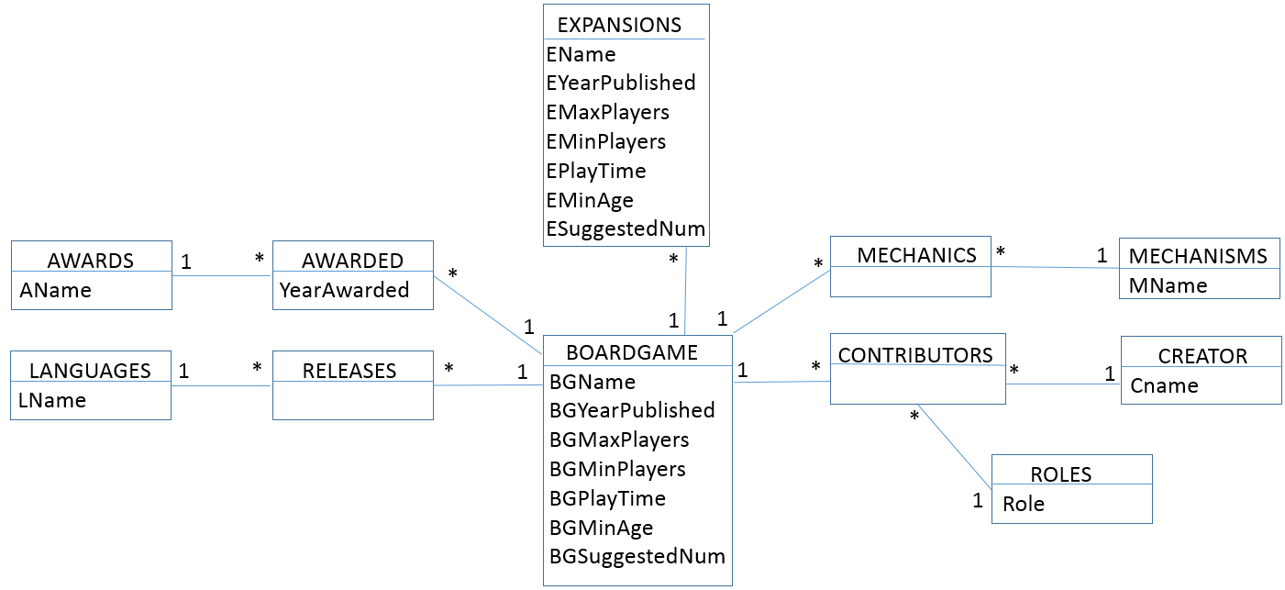

Figure 1: Class Diagram

1. RELATIONAL SCHEMA
   1. BOARDGAMES(BGId, BGName, BGYearPublished, BGPlaytime, BGMinAge, BGMaxNumber, BGMinNumber, BGSuggestedNum)
   2. EXPANSIONS(EId, EName, EYearPublished, EPlaytime, EMinAge, EMaxNumber, EMinNumber, ESuggestedNum, “BaseBGId”)
   3. MECHANICS("BoardgameId", "MechanismId")
   4. MECHANISMS(MId, Mechanism)
   5. CONTRIBUTORS("RoleId", “CreatorId”, "BoardgameId")
   6. CREATOR(CId, CName)
   7. ROLES(RId, Role)
   8. RELEASES("BoardgameId", "LanguageId")
   9. LANGUAGES(LId, Language)
   10. AWARDED("BoardgameId", "AwardId", YearAwarded)
   11. AWARDS(AId, AName)
2. USER GUIDE
   1. Introduction

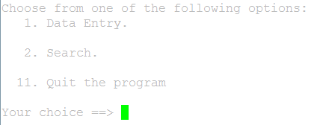

Figure 2: Start Menu

* + 1. Data Entry users are responsible for making additions to the board game database and have write access to the tables. Select option #1 to enter this portion of the interface.
    2. Searching is the primary function of the database, to find board games of interest and information about them. Select option #2 to enter this portion of the interface.
    3. See Appendix A for the Data Entry user guide Appendbix B for the and Search user guide.

1. CONTRIBUTION REPORT
   1. See Appdnebix C for Ben Price’s contribution report and Appendix D for Stephen Turner’s.